Edge Router

🌍 What is an Edge Router?
# Source: Chatgpt (GPT‑5 Mini) at [12/18/2025]
An Edge Router (also called a gateway router or border router) is a device that sits at the boundary between two networks, such as:
- A private network (like an organization’s internal network)
- The public internet or another external network
It routes data in and out of the internal network and is often the first point of contact with the outside world.

🔧 Key Functions of an Edge Router
# Source: Chatgpt (GPT‑5 Mini) at [12/18/2025]
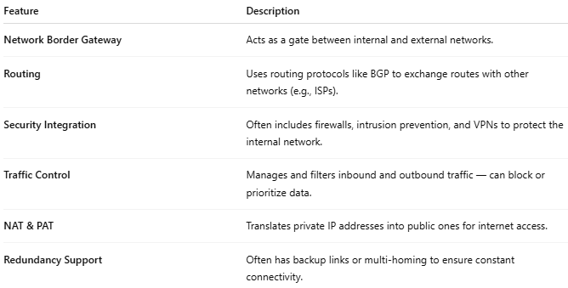

Feature | Description
Network Border Gateway | Acts as a gate between internal and external networks.
Routing | Uses routing protocols like BGP to exchange routes with other networks (e.g., ISPs).
Security Integration | Often includes firewalls, intrusion prevention, and VPNs to protect the internal network.
Traffic Control | Manages and filters inbound and outbound traffic — can block or prioritize data.
NAT & PAT | Translates private IP addresses into public ones for internet access.
Redundancy Support | Often has backup links or multi-homing to ensure constant connectivity.

📍 Where Edge Routers Are Used
# Source: Chatgpt (GPT‑5 Mini) at [12/18/2025]
- At the edge of an enterprise network (connecting to an ISP)
- At the edge of a data center (exchanging traffic with the outside)
- At the edge of an ISP’s network, interfacing with customer or partner networks

🖥️ Example Edge Router Use
# Source: Chatgpt (GPT‑5 Mini) at [12/18/2025]
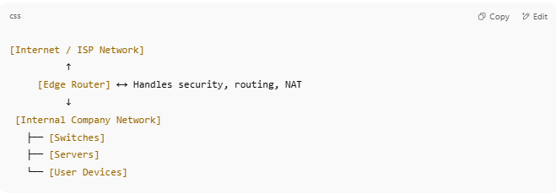

[Internet / ISP Network]
↑
[Edge Router] ←→ Handles security, routing, NAT
↓
[Internal Company Network]
├── [Switches]
├── [Servers]
└── [User Devices]

🆚 Comparison: Edge Router vs Core Router
# Source: Chatgpt (GPT‑5 Mini) at [12/18/2025]
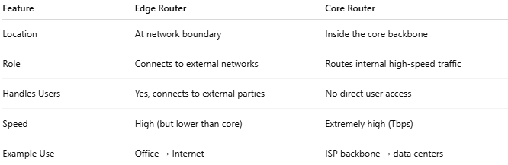

Feature | Edge Router | Core Router
Location | At network boundary | Inside the core backbone
Role | Connects to external networks | Routes internal high-speed traffic
Handles Users | Yes, connects to external parties | No direct user access
Speed | High (but lower than core) | Extremely high (Tbps)
Example Use | Office → Internet | ISP backbone → data centers

🔒 Common Features in Enterprise Edge Routers
# Source: Chatgpt (GPT‑5 Mini) at [12/18/2025]
- VPN Gateway
- Firewall or UTM (Unified Threat Management)
- BGP or static routing
- Load balancing
- Redundant uplinks (failover)

